

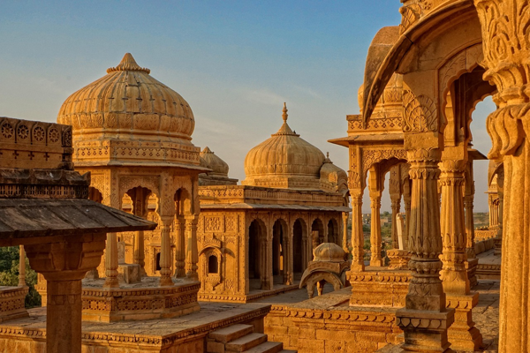

**Day 9: Valley of Colors**

Travel Time Distance: Local transit, minimal travel.   
Visit Nishat Bagh and Shalimar Bagh in the morning, known for their beautiful floral designs. Enjoy a relaxed afternoon, savoring authentic Kashmiri cuisine at a houseboat restaurant. Post-lunch, visit the old city’s historic Jamia Masjid. End your day with a walk along the Dal Lake embankment, enjoying the sunset views.   
  
---